**Cryptoverse:A Cryptocurrency Dashboard**

**Introduction**

* Project title: Cryptoverse currency dashboard
* Team members: Dhanalakshmi.H – dhanalakshmihari9190@gmail.com

Sandhiya.K – sandhiyaksandhiyak42@gmail.com

Gopika.V – gopikagopika848@gmail.com

Sivaranjini.A - gaganasindhu742k21@gmail.com

Nabitha.A - anadhannabitha@gmail.com

**Project Overview:**

* **Purpose:**

The Cryptoverse Currency Dashboard is designed to provide users with real-time insights and analytics related to cryptocurrency markets. Its primary purposes include:

1. Live Market Data – Display real-time prices, market capitalization, trading volume, and other key metrics for various cryptocurrencies.
2. Portfolio Tracking – Allow users to monitor their crypto holdings, track profits/losses, and view historical performance.
3. Analytics & Charts – Offer visual representations of price trends, volatility, and market dominance through graphs and charts.
4. News & Updates – Provide the latest cryptocurrency news, regulatory updates, and market trends.
5. Conversion & Exchange Rates – Show currency conversion rates between different cryptocurrencies and fiat currencies.
6. Alerts & Notifications – Notify users about price changes, significant market movements, and trading signals.

* **Feature:**

A Cryptoverse Currency Dashboard typically includes the following features:

1. Real-Time Market Data

Live price updates of top cryptocurrencies (BTC, ETH, BNB, etc.)

Market capitalization and trading volume

Percentage change over different timeframes (24h, 7d, 30d)

Highs and lows for the selected period

2. Interactive Charts & Analytics

Candlestick and line charts for price trends

Historical data with different time intervals

Market dominance and trend indicators

Technical analysis tools (moving averages, RSI, MACD)

3. Portfolio Management

Track user investments and holdings

Calculate profit/loss in real-time

Support for multiple wallets and exchanges

Customizable alerts for price changes

4. Crypto Converter & Exchange Rates

Convert between cryptocurrencies and fiat currencies

Display real-time exchange rates

Support for major fiat currencies (USD, EUR, INR, etc.)

**Setup Instructions:**

* **Prerequisites:**

A Cryptocurrency Dashboard requires a combination of frontend, backend, APIs, security measures, and hosting infrastructure to function effectively. For the frontend, technologies like HTML, CSS, and JavaScript are essential, while frameworks such as React.js, Vue.js, or Angular enhance dynamic UI capabilities. Charting libraries like Chart.js, D3.js, or ApexCharts are crucial for visualizing real-time and historical price data. On the backend, programming languages such as PHP, Python (Django/Flask), or Node.js help manage server-side logic, while databases like MySQL, PostgreSQL, or MongoDB store user data and transaction records.

APIs play a critical role in fetching live crypto prices, market trends, and historical data, with popular choices including CoinGecko, CoinMarketCap, Binance, and CryptoCompare APIs. Security measures such as user authentication (OAuth or JWT), HTTPS encryption, and rate limiting ensure safe and efficient data handling. Additionally, the dashboard should offer key features like real-time price updates, portfolio tracking, historical price charts, news integration, and currency conversion to enhance user experience. For deployment, hosting services such as AWS, DigitalOcean, Firebase, or Vercel provide a reliable infrastructure, while CI/CD pipelines help automate updates.

A well-structured admin panel can further assist in managing users, API limits, and other critical settings. Properly integrating these components ensures a seamless, secure, and user-friendly cryptocurrency dashboard.

* **Installation:**

1. Open your terminal and run:

**git cloneGlo**

1. Move into the project folder:

**cd project_cryptoverse**

1. Run the following command to install required packages:

**npm install**

1. Run the following command:

**npm start**

This will start the development server, and you can access Cryptoverse at:  
📌 <http://localhost:3000>

**State Management:**

* **Global State:**

The global state stores essential cryptocurrency data, including real-time prices, historical trends, market statistics, and exchange details, all fetched from the RapidAPI service. It is structured using Redux slices, where each slice represents a specific feature, such as cryptoApiSlice for cryptocurrency data and newsApiSlice for crypto-related news.

These slices utilize createApi from Redux Toolkit Query (RTK Query) to make asynchronous API calls, cache responses, and automatically refetch data when needed. The state is accessed globally using useSelector for retrieving data and useDispatch for triggering actions, ensuring smooth updates across components. This approach optimizes performance by minimizing redundant API calls and providing a seamless user experience in displaying market trends, news, and exchange statistics dynamically.

* **Local State:**

The local state is responsible for managing UI-related data that does not need to persist across multiple components, such as loading states, search filters, active tab selections, dropdown menus, and modal visibility. By leveraging React’s built-in state management, the application ensures efficient rendering, reducing unnecessary global state updates and improving performance.

Additionally, useEffect is used to handle side effects, such as fetching data on component mount or updating the UI in response to user interactions. This hybrid approach of combining local state for UI control and global state for shared cryptocurrency data ensures a highly responsive and scalable application.

**Styling:**

* **CSS Frameworks/Libraries:**

The Cryptocurrency Dashboard utilizes modern CSS frameworks and libraries to ensure a visually appealing, responsive, and user-friendly interface. Popular choices include Tailwind CSS, known for its utility-first approach, enabling rapid styling with minimal custom CSS. Alternatively, Bootstrap provides a grid system and pre-designed components for a structured layout. Ant Design is often used for dashboards due to its ready-to-use UI components, such as tables, charts, and modals.

For advanced data visualization, libraries like Chart.js, Recharts, or D3.js are integrated to display cryptocurrency price trends and analytics effectively. Additionally, Styled Components or CSS Modules can be used in React-based applications for scoped styling, ensuring maintainability. Combining these CSS frameworks and libraries ensures a sleek, responsive, and interactive cryptocurrency dashboard that enhances the overall user experience.

* **Theming:**

It is typically implemented using CSS variables, Tailwind CSS themes, Styled Components, or Ant Design’s theming system. A global theme state is managed using React Context API or Redux, allowing users to toggle between themes dynamically. Dark mode is particularly popular in financial dashboards as it reduces eye strain and enhances data visibility.

**SAMPLE CODING:**

**Screenshots:**

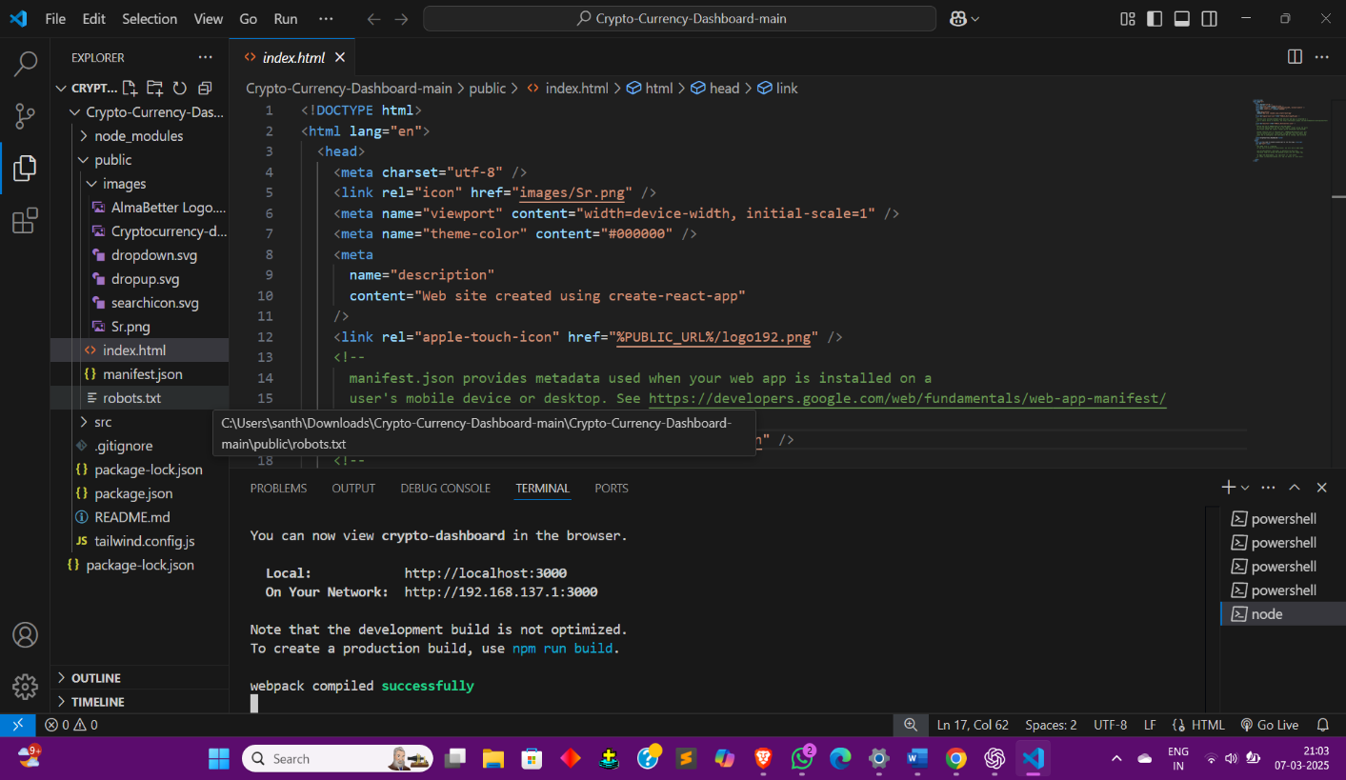

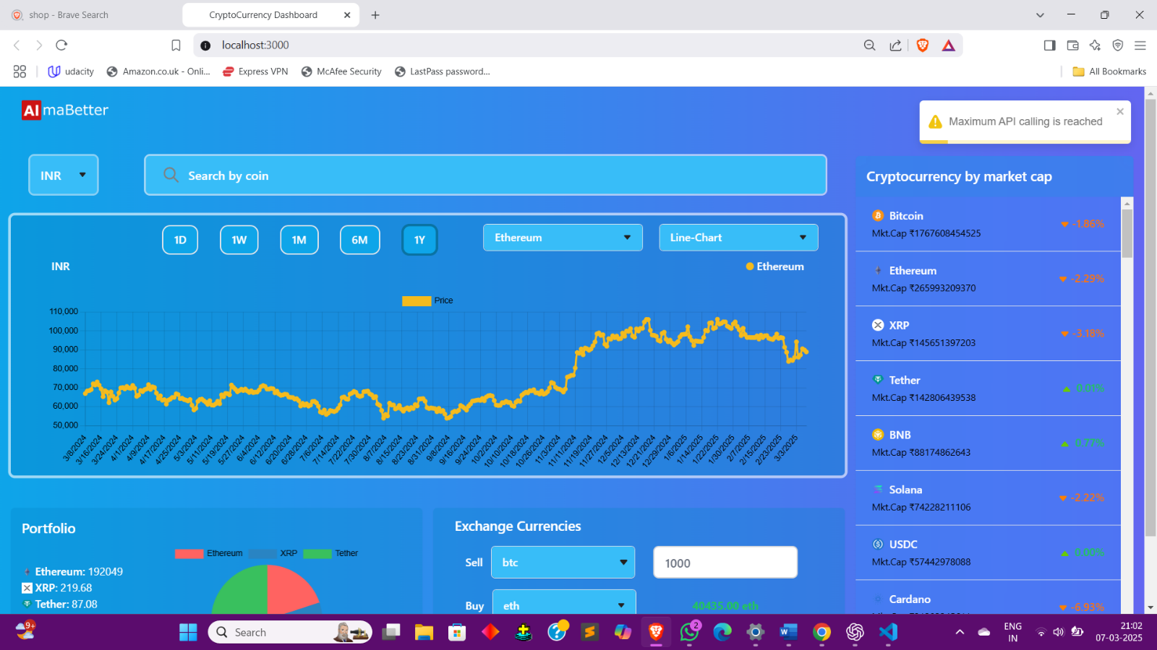

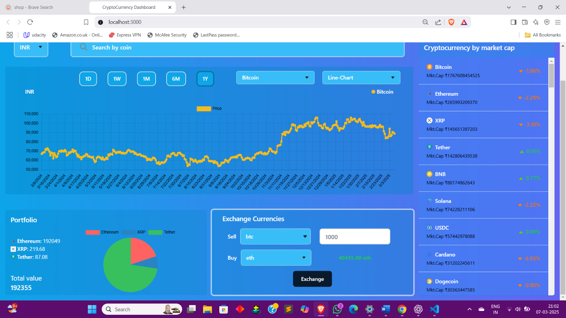

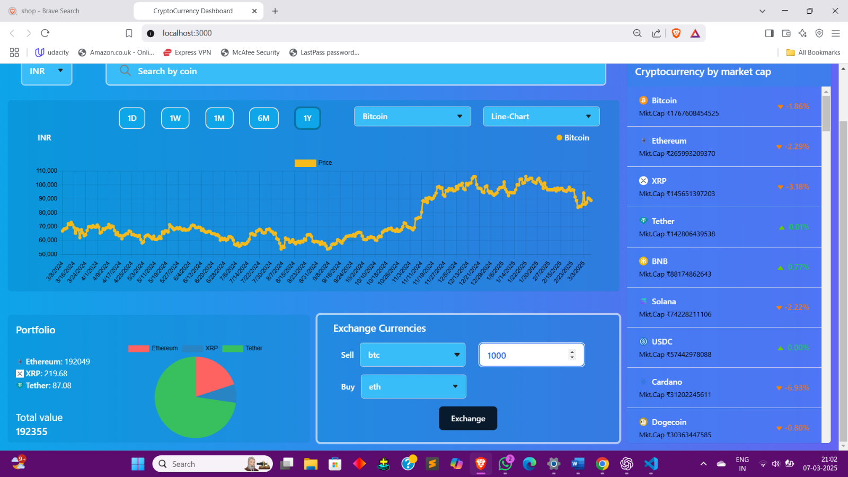

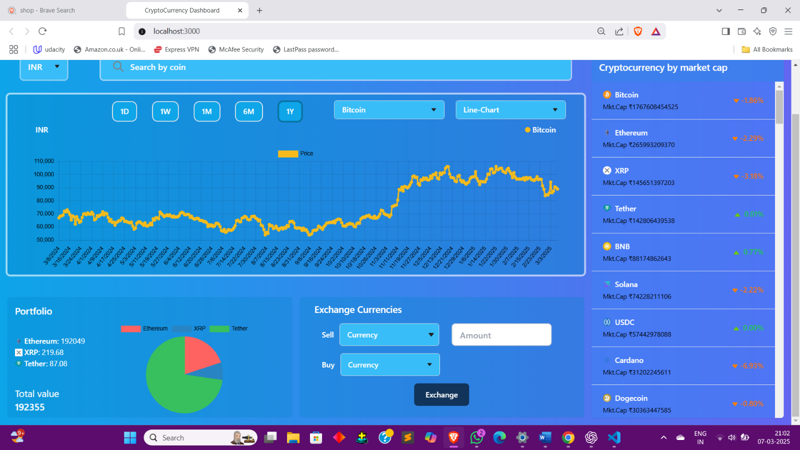

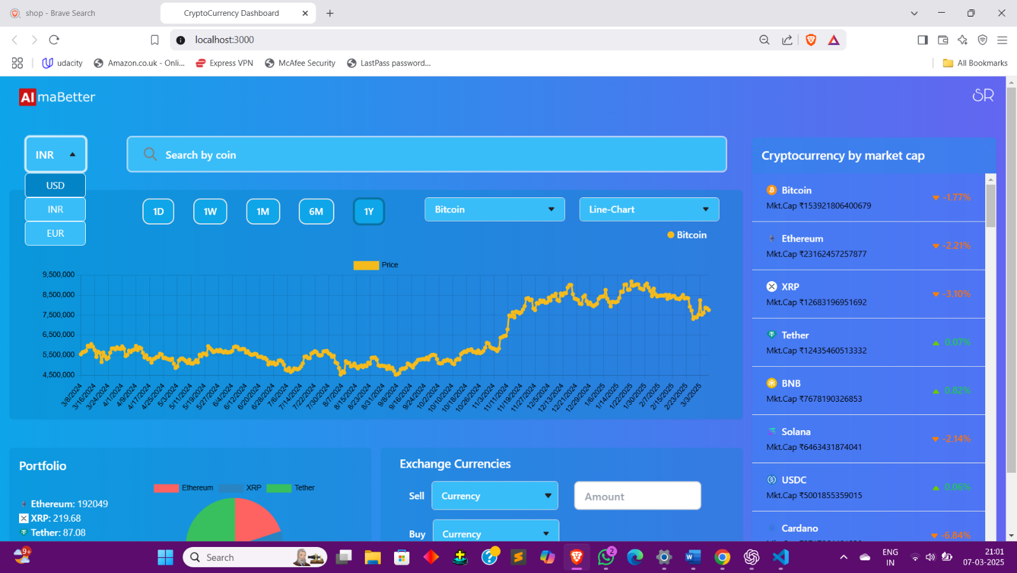

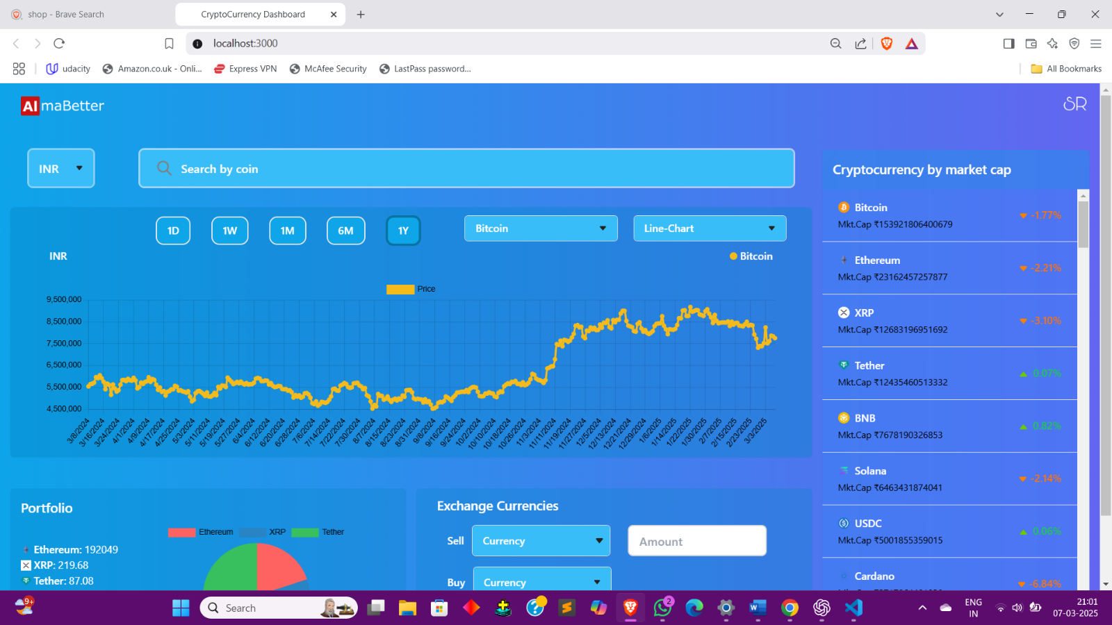

**Future Enhancements:**

1. AI-Powered Price Predictions – Implement machine learning models to analyze market trends and provide predictive insights on cryptocurrency prices.
2. Advanced Portfolio Management – Allow users to link wallets, track profit/loss, set alerts for price changes, and generate detailed financial reports.
3. Multi-Currency Support – Expand fiat currency conversions beyond USD to include other global currencies like EUR, GBP, and INR.
4. Real-Time WebSocket Integration – Replace REST API calls with WebSockets for ultra-fast live price updates without frequent API requests.
5. Decentralized Exchange (DEX) Integration – Enable users to trade cryptocurrencies directly from the dashboard by integrating with DEX platforms like Uniswap and PancakeSwap.
6. Customizable Dashboard & Themes – Offer users the ability to personalize the dashboard layout, widgets, and color schemes.
7. Social Trading & Community Features – Add a feature where users can follow expert traders, view market sentiment analysis, and participate in discussions.
8. News Sentiment Analysis – Use AI to analyze cryptocurrency news and social media trends to provide insights into market movements.
9. Mobile App Development – Develop a mobile-friendly version of the dashboard for iOS and Android to enhance accessibility.
10. Security Enhancements – Implement multi-factor authentication (MFA), blockchain-based security, and end-to-end encryption to improve data protection.

These enhancements will significantly boost the dashboard’s functionality, making it more efficient, user-friendly, and competitive in the evolving cryptocurrency market.

**Conclusion:**

The Cryptoverse Cryptocurrency Dashboard provides a seamless and interactive platform for tracking real-time cryptocurrency prices, market trends, and financial insights. Overall, Cryptoverse serves as a dynamic and user-friendly solution for both casual investors and professional traders, making cryptocurrency tracking more accessible and insightful.